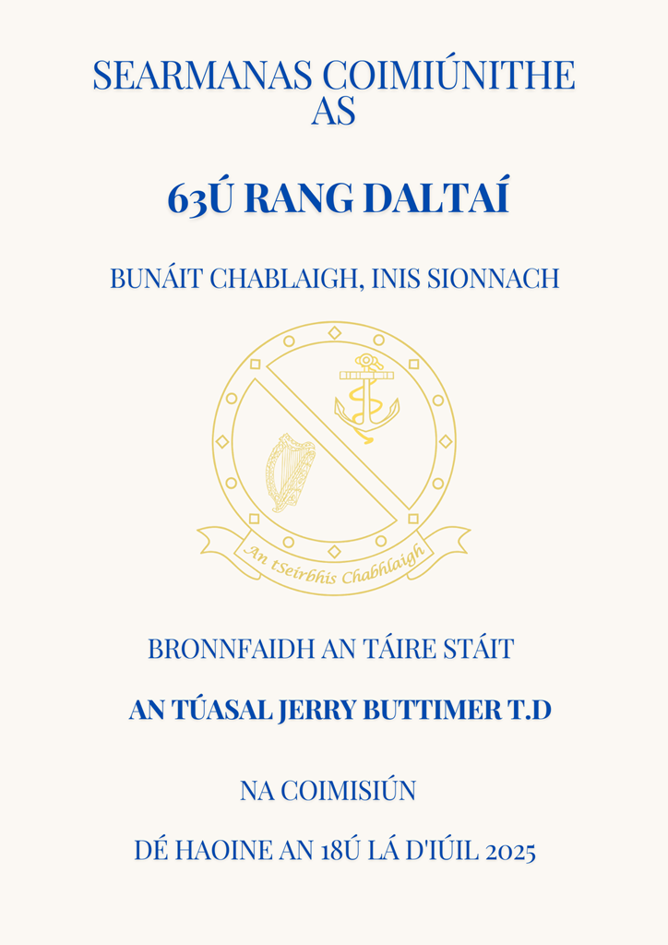

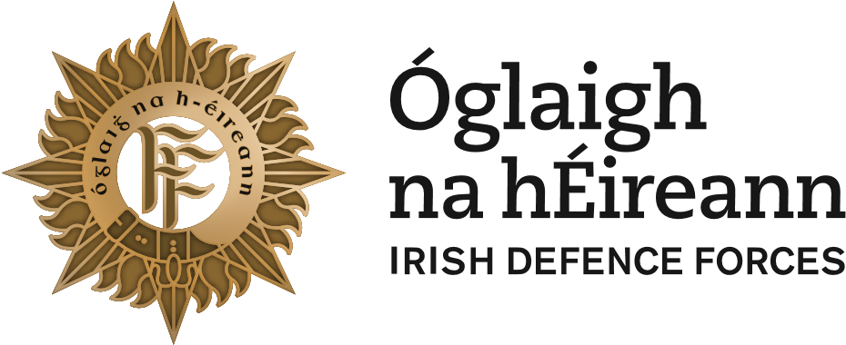

**Searmanas Coimisiúnaithe an 63ú Rang Daltaí**

Bunáit Chablaigh, Inis Sionnach

An tAire Cosanta

An tUasal Jerry Buttimer T.D.

Dé hAoine, an 18ú lá Iúil 2025

**Commissioning Ceremony of the 63rd Cadet Class**

Naval Base, Haulbowline

Presentation of Commissions by

Minster Mr. Jerry Buttimer T.D.

Friday, 18th July 2025

**COIMISIÚNÚ**

Tá an tSeribhís Chablaigh, atá Lonnaithe ar Inis Sionnach i gCuan Chorcaí, ina bhall de Fórsaí Chosanta na hÉireann. Tá na Daltaí tar éis dhá bhliain a chaitheamh faoi stiúir oifigigh ón Choláiste Chablaigh agus séard atá sa searmanas inniú ná bronnadh na gcomisiúin agus comóradh go bhfuil an staíd seo bainte amach acu ar an ród seo rompu.

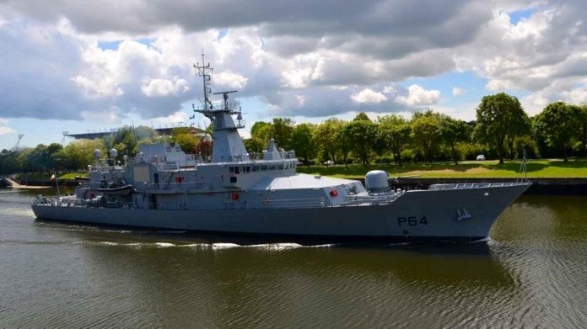

The Naval Service, which is based on Haulbowline Island in Cork Harbour, is the maritime component of the Irish Defence Forces. The Cadets have spent the last two years under the guidance of the Officer Training School staff. This ceremony is the award of their commissions and is a declaration that they have achieved the required standard to become officers in the Irish Naval Service.

**FÁILTE**

On this significant occasion, I would like to congratulate the members of the 63rd Naval Cadet Class on your Commissioning Day and to welcome you all as the newest Junior Leaders in our Naval Family.

Today marks the final day of your formal Cadetship training, however, your journey does not stop here. Leadership requires lifelong study and experiential learning and to practice it requires skill, reflection and imagination. All of which, through the duration of this Cadetship, has been proven to be well within your ability.

I wish to thank the Officers and Staff of the Officer Training School, whose efforts do not go unrecognised and who do such fine work in turning out high calibre individuals.

On behalf of the Naval Service, I wish to extend a warm welcome to the Minister of State for Rural and Community Development, the Gaeltacth and Department of Transport Mr. Jerry Buttimer, T.D., on the occasion of this Commissioning Ceremony.

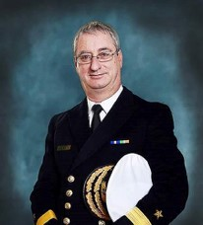

I wish to extend a sincere welcome to the Chief of Staff, Lt Gen Rossa Mulcahy, members of the General Staff and to all other military and civic dignitaries present.

I also want to extend a warm welcome to the family and friends of the 63rd Naval Cadet Class. As members of our wider Naval Family, your continued support and kinship is integral to the success of our Naval Service.

**Michael Malone**

**Commodore**

**Flag Officer Commanding Naval Service**

**THE NAVAL COLLEGE STAFF FOR THE 62nd CADET CLASS WERE:**

**OFFICER COMMANDING &**

**COMMANDANT NAVAL COLLEGE:** **CDR** **Roberta O’Brien**

**OFFICER IN CHARGE**

**OFFICER TRAINING SCHOOL:** **LT CDR Aoife Campbell**

**CLASS OFFICER 63RD CADET CLASS:** **LT(NS) Robert Fabby**

**NCO I/C OFFICER TRAINING SCHOOL:** **CPO Andrew Hickey**

**CLASS NCO 63RD CADET CLASS:**  **PO David Foley**

**THE 63rd CADET CLASS:**

On the 18th of September 2023, the 63rd Cadet Class were inducted into the Irish Naval Service and began their training in the Officer Training School. In the first two weeks, the 63rd Cadet Class were introduced to the Naval Service through learning about basic navigation principles, RHIB handling in Cork Harbour, and had their first two weeks highlighted by the LE William Butler Yeats’ interdiction of the MV Matthew, before moving to the Cadet School at the Military College in the Curragh Camp, Kildare. Here, the Cadets were given basic military training, focusing on foot and arms drill, marksmanship, military discipline, physical and military fitness and land navigation. In December 2023, the 63rd Cadet Class moved back to Haulbowline to begin Phase 2 of their Training.

Phase 2 of training commenced in January 2024 with a busy schedule ahead. This ‘Marinisation’ phase ran from January to May with the Cadets studying navigation while also completing a range of courses and assessments in disciplines such as:

* Engineering
* Communications
* Maritime Interdiction
* Fisheries
* Gunnery
* Strategic Studies
* Seamanship

The 63rd Cadet Class also gained the opportunity to spend time aboard LE James Joyce during their sea familiarisation week, becoming familiar with the ship's daily routine, the different branches that operate on board, and the ranges on Bear Island.

Phase 2 concluded with exams in General Navigation, Chart work, Rules of the Road, Leadership and Communications.

**THE 63rd CADET CLASS:**

On completion of Phase 2, the 63rd Cadet Class had the opportunity to travel to Lourdes and partake in the Annual International Military Pilgrimage as is the tradition, allowing them to socialise and network with their military peers from other nations. On their return, the class continued their training, participating in their senior class’ personal leader exercise over 3 days, as well as joining the Brian Ború for sail training for 2 weeks, sailing from Cork Harbour to Caernarfon, Wales building on their navigation and ship handling skills, before joining LE William Butler Yeats and LÉ James Joyce to commence phase 3 of their training. On board LÉ William Butler Yeats and LÉ James Joyce, the 63rd Cadet Class started to learn about life at sea. They understudied all of the roles, which included Seamanship, Gunnery, and Communications, Logistics, & Engineering.

Phase 4 commenced in September 2024 with the 63rd Cadet Class studying in the National Maritime College of Ireland (NMCI) in Ringaskiddy. Studying alongside civilian students, the Cadets learned various maritime subjects such as astronavigation, seamanship, maths, science and stability. Even though the Cadets were studying in NMCI their duties as Naval Cadets were not forgotten.

Regularly the cadets practised their pilotage skills with their Class Officer LT (NS) Robert Fabby in the simulators, with the target of becoming competent enough to navigate a ship for the first time, with PO/Sea David Foley, ensuring that standards were kept high, that the cadets maintained the highest level of conduct and discipline, throughout.

After 22 months of training, the 63rd Cadet Class will take the next step in their careers.

**THE COMMISSIONING CEREMONY:**

The Commissioning Ceremony is the formal presentation to the Cadet Class of their Commissions upon completion of their training as Cadets. It marks their graduation to the officer body of the Naval Service.

The Commission is the direction from the President, as the Commander in Chief of the Defence Forces, to exercise and train in arms and maintain in good order and discipline the men and women serving under them. The Commissioning scroll presented by the Minster, appointing each new officer, is signed by an tUachtarán on behalf of the state, and also by An Taoiseach and the Minister for Defence on behalf of the Government.

**TIMELINE & OUTLINE OF CEREMONY:**

**1050** – Chief of Staff arrives at the Naval Base

**1100** – Minister arrives at the Naval Base

**1135** – Guard of Honour Falls in

**1140** – All Guests to be seated

**1145** – Minister arrives and inspects Guard of Honour

**1200** – Commissioning Ceremony Commences

The Commissioning Ceremony begins with the marching on Parade of the National Colours. The Colour party takes up its position facing the Cadets to be commissioned. The Officer administering the Oath calls each Cadet by name. The Cadets will then march forward to the Colours where the Oath is administered. The Cadets are invested with their rank markings and receive their swords.

Individually, each cadet will march forward to the Minister for Defence, and be presented with their commission as an officer in the Naval Service.

The newly commissioned officers now hand their commission to the Master at Arms, the highest ranking Non-commissioned officer of the Service, from whom they in return receive their first salute as an officer.

A representation on behalf of the Association of Retired Commissioned Officers (ARCO) will then present the Perpetual Trophy to the Best Overall Cadet. On completion of the presentation, the National Colours are marched off parade.

The Minister for Defence will then address the parade. The National Anthem will then be played, after which the Minster for Defence will leave the Parade ground.

The Parade Commander will dismiss the parade and the ceremony will be complete.

Martin McHale

**PARADE FORMATION**

LT (NS) Fabby

Oisín Anderson

**CADET PROFILES:**

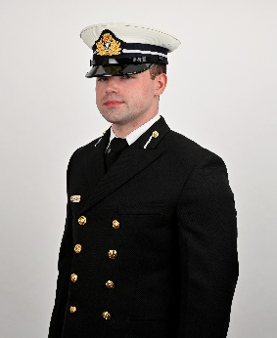

***Oisín Anderson***

Oisín is the son of Maura and Dermott, brother to Jayne, and engaged to Helena. He grew up in Sligo town, and attended Ballinode Community College before studying at ATU Sligo, graduating with an Honours Degree in Human Resource Management. Before joining the Navy, he worked as a Wedding and Events Manager. Oisín has a keen interest in automotive engineering and weightlifting, as well as travel and cinema. Oisín’s favourite parts of the Cadetship was his time in the Curragh and being out at sea, on-board the LE William Butler Yeats and the LE James Joyce.

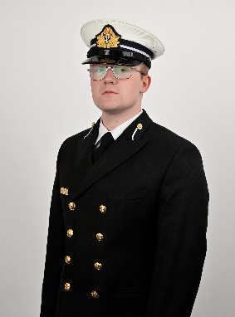 ***Martin McHale***

Martin was born in Limerick and moved to Enniscrone in County Sligo to Martin and Lisa McHale with a younger sister Aisling being born later on. Martin attended the local secondary school, Jesus and Mary Secondary School where upon graduated joined the civil service as part of the Department of Foreign Affairs. He has a deep interest in Irish history, film and photography as well as fitness. He enjoyed his cadetship with a two-week sailing trip around the southeast coast of Ireland, as well as a trip to Wales on the Brian Ború being a highlight of his time.

**FOIRM AN MHIONNA:**

Mionnaímse (nó dearbhaímse), go solamánta go mbead dílis d’Eirinn, agus tairiseach don Bhunreacht agus, faid a bhead im oifigeah de na Buan-Óglaigh, go gcomhlíonfad gach ordú dleathach a bhéarfas m’oifigigh uachtaracha dhom, agus nach gceanglód le haon eagraíocht, nó cumann polaitíochta, ná le haon chumann rúnda ar bith, ná nach mbead im chomhalta den chéanna ná nach dtaobhód leis an gcéanna.

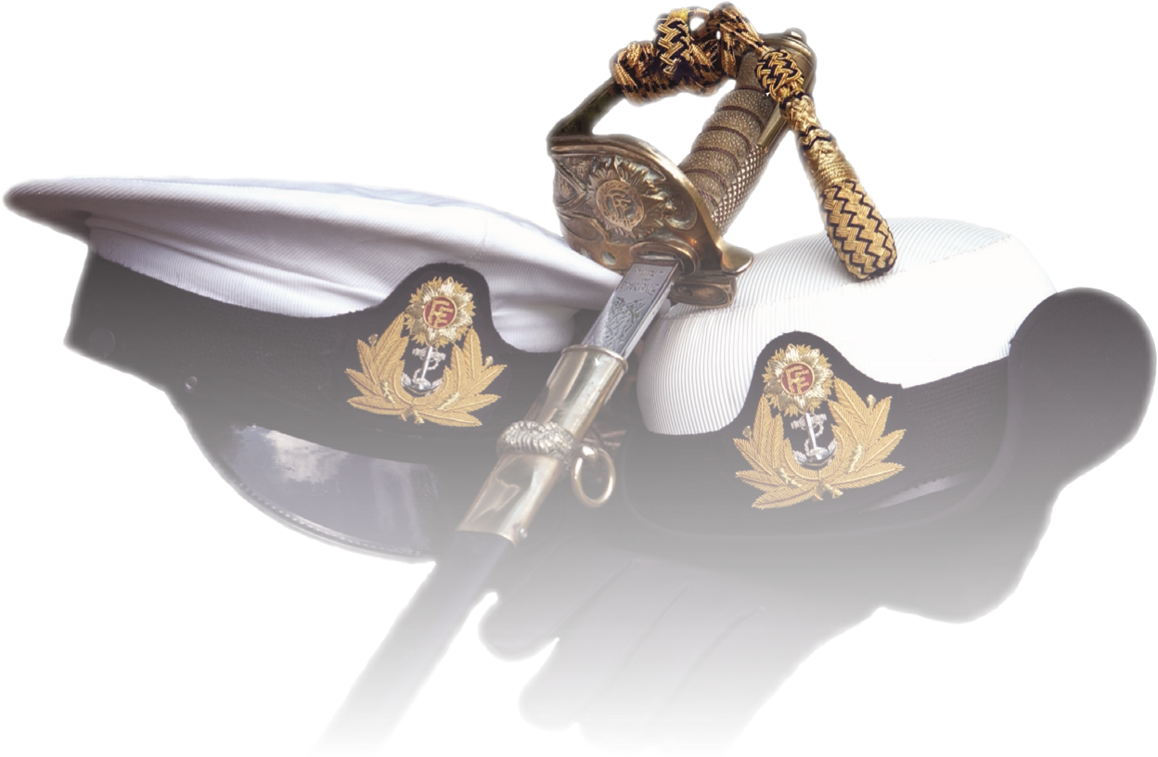

**FORM OF OATH:**

I, do solemnly swear (or declare), that I will be faithful to Ireland and loyal to the constitution and while I am an Officer of the Permanent Defence Forces, I will obey all lawful orders issued to me by my Superior Officers and will not join or be a member of, or subscribe to any political organisation, or society, or any secret society whatsoever.

**A NAVY DELIVERING SERVICES:**

The Naval Service is the State’s principal sea going agency and an integral part of Óglaigh na hÉireann/The Defence Forces. The Service operates jointly with the Army and Air Corps.

To exercise and uphold our State’s sovereignty and obligations, the Naval Service patrols Ireland’s 220 million maritime acres which is an area 12 times larger than the island of Ireland.

The Naval Service keeps Ireland open for business as 99% of trade, on and off our island nation, is transported by sea. Naval ships carry a unique status under international law as an expression of State sovereignty and political will at sea and are critical enablers for furthering policy objectives at home and in the international maritime domain.

The Government’s requirement for a flexible force with an appropriate level of retained capability means in effect that the Naval Service, in addition to meeting defence requirements, can deliver a wide range of services at and from the sea. The enduring characteristics of naval vessels such as sovereign status, poise, political utility, versatility, self-sustainability, long reach, and rapid response facilitate a variety of roles including inter alia:

|  |  |
| --- | --- |
| * Maritime Defence and Security Operations * Crisis response * Fishery Protection * Drug Interdiction * Diving Operations * Search and * Rescue/Recovery * Maritime Interdiction Operations | * Support to Trade and Diplomacy * Humanitarian Support & Assistance * Non-combatant operations * Weather Reporting * Fire Fighting * Pollution Control/Towing * General Maritime Support |